Section 9.1 - Polynomial equations in factored form
Solve Hints: Don't simplify, and there is more than one solution

Solve (2x-7)(x+5) = 0

Zero-product property

Solve 4x(x+6)(4x-9) = 0

Solve x² -4x = 0
Factoring
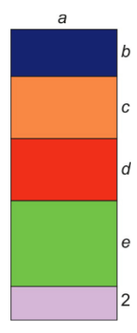
What is the area of each rectangle?

What is the area of the total figure?
Write it in two different ways

Expanded form factored form

Last operation when evaluating

Units we use

Review:

Find the prime factorization

12

54

140

23
Find the GCF of 140 and 54

Find the GCF of 12, 27, and 54

Find the GCF of 23 and 92

Find the GCF of 23 and 42

Find the GCF of 30x² and 18x³

Find the GCF of 54x²y³z and 140x⁵y²

Find the GCF of 30a²bc, 27ab and 15b²c
Factor out the greatest common factor
2x + 8

Factor out the greatest common factor
15x - 25

Factor the GCF
12a⁴ - 5a³ + 7a²

Factor the GCF
45xy¹² + 24xy¹⁰ - 36y⁸

Solve

Solve
Section 9.2 - Factoring Quadratic Expressions
Simplify the following:
(x + 2)(x + 3)

(x + 2)(x - 3)

(x - 2)(x + 3)

(x - 2)(x - 3)

Quadratic polynomials are polynomials of the 2nd degree, and can be written
We will start by factoring quadratics of the form

This will factor in the form of (x + m)(x + n).

To proceed, we need to find m and n

How do m and n relate to b and c?
Factor
x² + 8x + 12

